🧩 1. Interface Diagram (System Architecture / Module Interaction)
An interface diagram (also called a system interface architecture diagram) shows how modules or components interact through defined interfaces (UI, database, services).
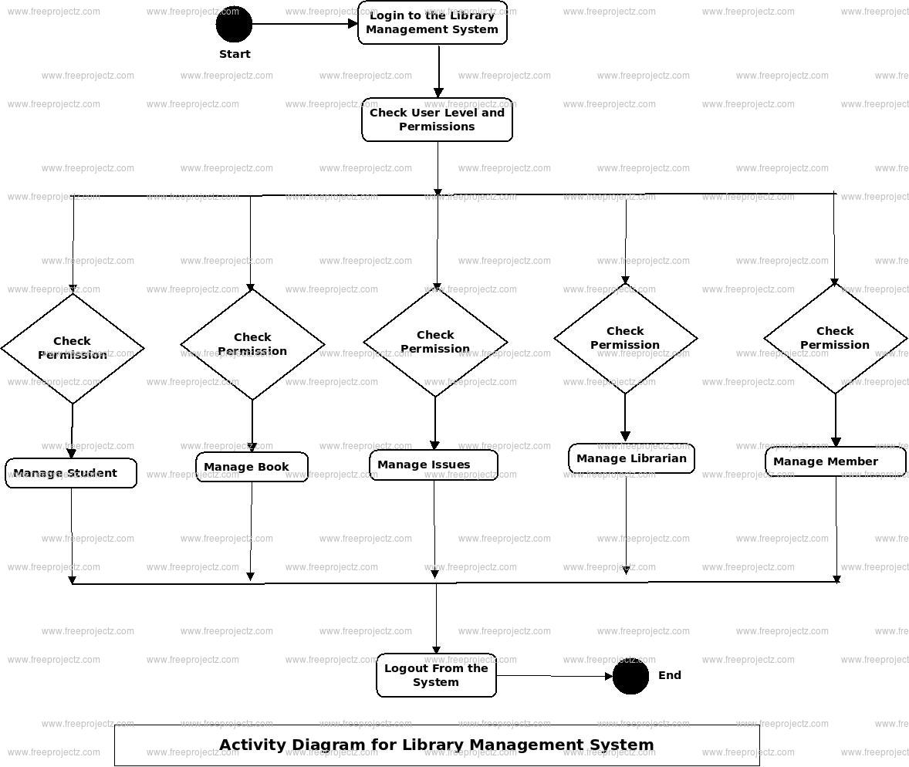

🧠 2. State Diagram (for Book Entity)
A State Diagram shows the life cycle of an object — in this case, how a Book moves through different states in the library system.
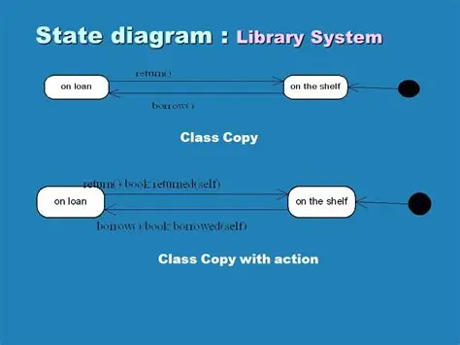

🔄 3. Activity Diagram (for Book Search & Recommendation)
An Activity Diagram represents the workflow of actions — like a flowchart.
